Project Title: Role-Based Employee Management System (C++ Console Application)



Submitted to: Miss Kishmala Tariq
Subject: Object Oriented Programming
Date: 4 June 2026.

Submitted by:
Ibrahim Haroon

DEPARTMENT OF SOFTWARE ENGINEERING
UNIVERSITY OF LAHORE

Project Overview
This project is a simple Employee Management System made in C++ using Object-Oriented Programming.
It works like a small office system where employees have different roles like HR, Manager, and Regular Employee. Each role has different permissions.
- HR can add, update, and delete employees
- Manager can assign tasks and manage leave requests
- Employees can view profile, submit tasks, and apply for leave
The system helps to manage employees and their work in an organized way using OOP concepts.

Objectives
- To use OOP concepts in a real program
- To create a role-based system (HR, Manager, Employee)
- To manage employee records
- To assign and track tasks
- To handle leave requests
- To understand how classes and objects work in real systems

Problem Statement
In real companies, employee records and tasks are often managed manually, which can cause mistakes and confusion.
This project solves that problem by making a simple digital system where everything is managed through a program in a structured way.

Functional Requirements
The system can:
- Add new employees
- Update employee details
- Delete employee records
- Show employee list (directory)
- Assign tasks to employees
- Submit task completion
- Request leave
- Approve or reject leave
- Show salary details

OOP Concepts Used
1. Encapsulation
All employee data is kept inside the Employee class and accessed using functions like getters and setters.
2. Classes and Objects
The whole system is built using one main class Employee, and multiple objects are stored in an array called database.
3. Abstraction
Users only see menus (HR, Manager, Employee), they don’t see internal working of the system.
4. Data Hiding
Important data like salary, task status, and leave status is private inside the class.
5. Constructor
A default constructor sets all values to safe default values when an object is created.
6. Role-Based Access
Access depends on the role stored in each employee (HR, Manager, Employee).

System Design
The system is built around one main class:
Employee
├── Personal Info (id, name, age, gender)
├── Job Info (department, designation, role, salary)
├── Task System (task, deadline, status)
└── Leave System (days, reason, status)
The system works using 3 portals:
- HR Portal → Manage employees
- Manager Portal → Assign tasks + handle leave
- Employee Portal → View profile + submit work + apply leave
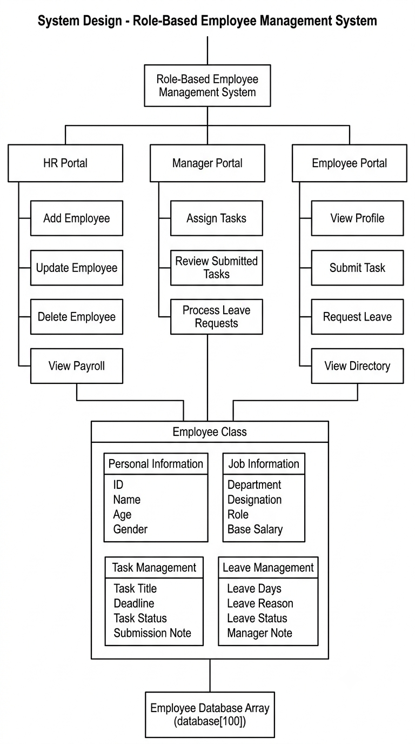

Class Description
Class: Employee
Purpose:
This class stores all employee data and handles tasks and leave system.
Attributes:
- id
- name
- age
- gender
- department
- designation
- role
- salary
- task details
- leave details
Functions:
- setData() → set employee information
- setTask() → assign task
- submitTask() → submit completed work
- requestLeave() → request leave
- processLeave() → approve/reject leave
- displayFullProfile() → show full employee info
- displayPublicRow() → show short directory view

Program Flow
- Program starts and shows main menu
- User selects HR, Manager, or Employee portal
- User enters ID for authentication
- System checks role
- Appropriate menu opens
- User performs actions (add, task, leave, etc.)
- Data updates in system memory
- User logs out or exits

Screenshots

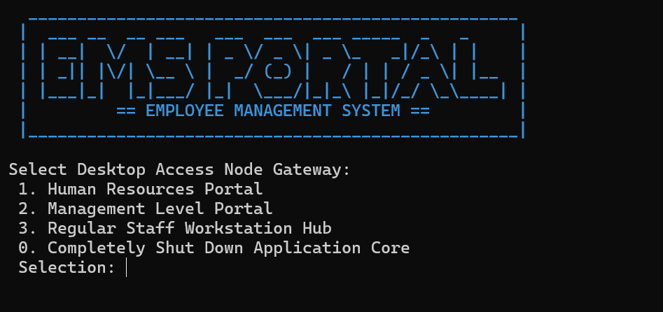
Main Menu Screen

HR Panel

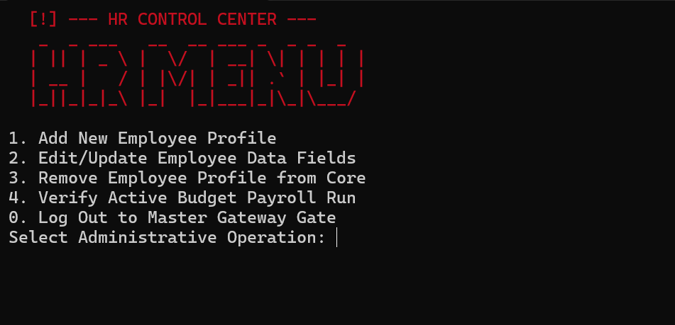

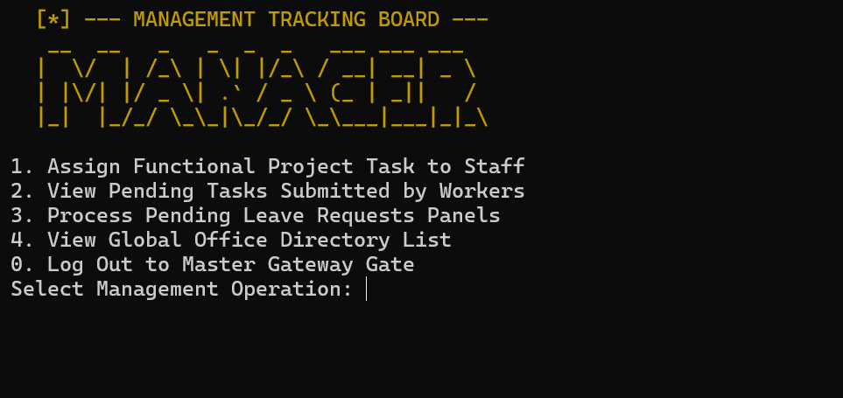
Manager Panel

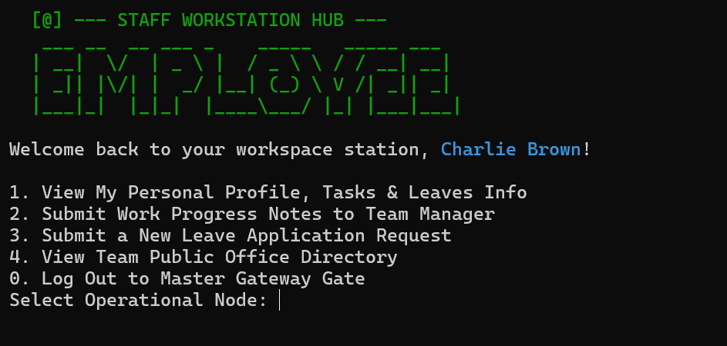
Employee Panel

Task Assignment Screen
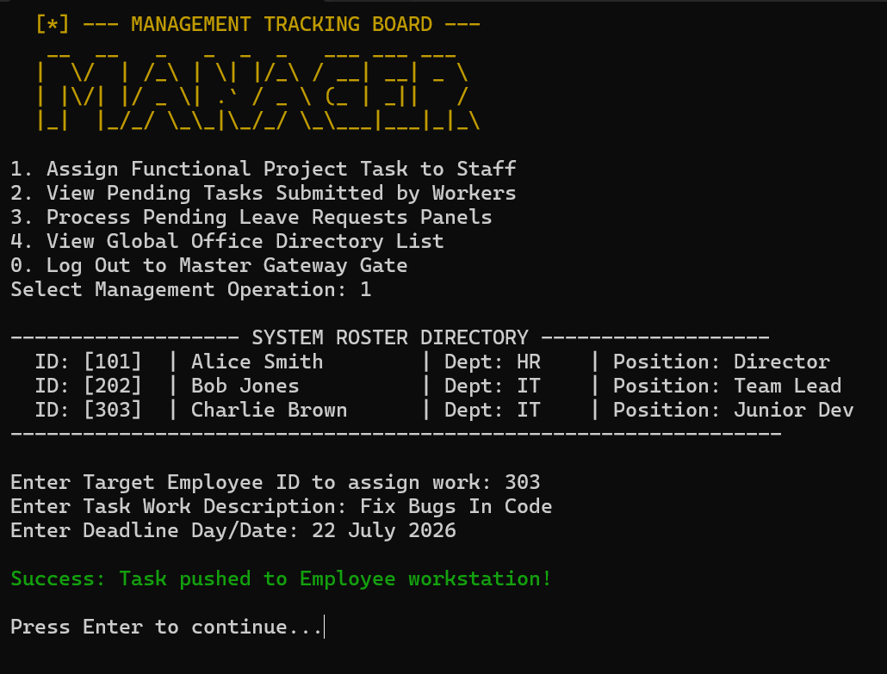

Leave Request

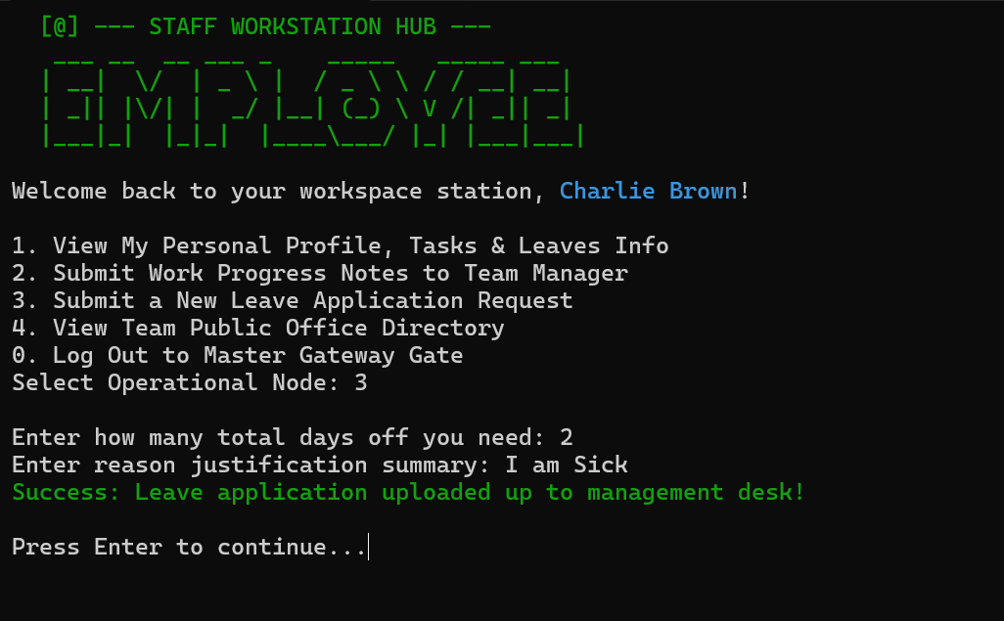

Employee Directory

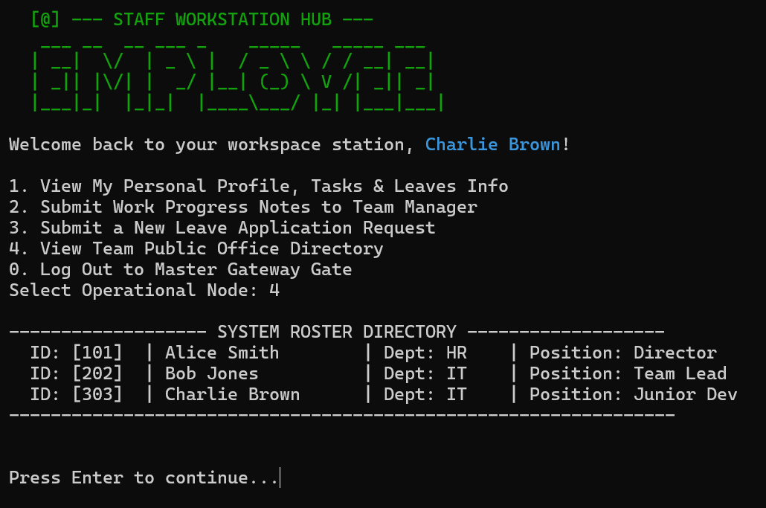
Future Improvements
- Add database instead of arrays
- Add login password system
- Create GUI version
- Improve UI design
- Add better reporting system

Conclusion
This project helped in understanding how Object-Oriented Programming is used in real systems.
It shows how employees can be managed using classes, how roles control access, and how tasks and leaves can be handled in a structured way.
Overall, it was a good practice to understand real-world system design in C++.

